|  |  |
| --- | --- |
| TEAM ID | PNT2022TMID30400 |
| PROJECT | IOT BASED SMART CROP PROTECTION FOR AGRICULTURE |

ACCOUNT CREATION IN CLARIFAI

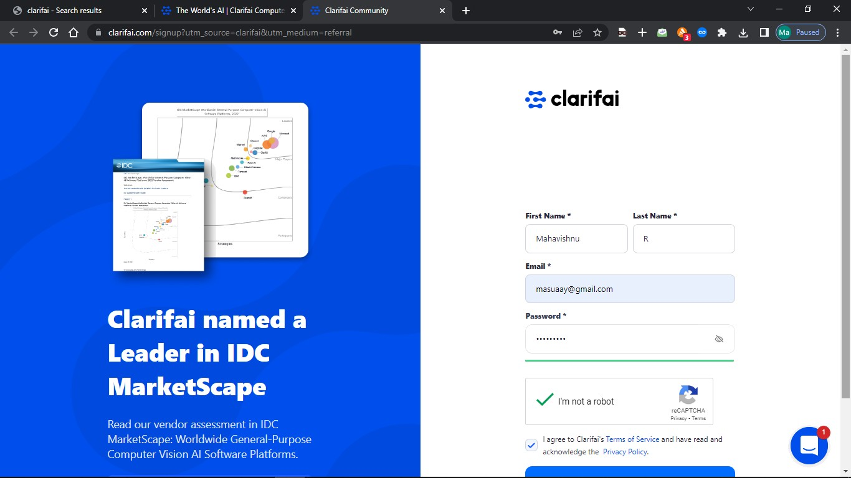

SignuptoClarifai's end-to-end AI platform forfree



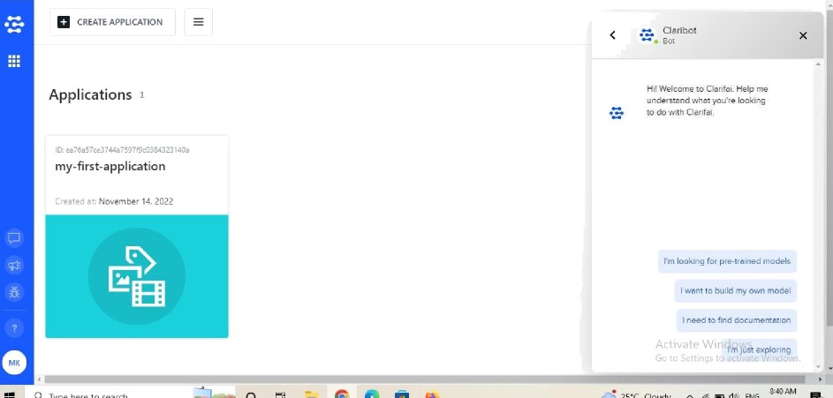



; ;; Apos @ GOOgIe Meet

